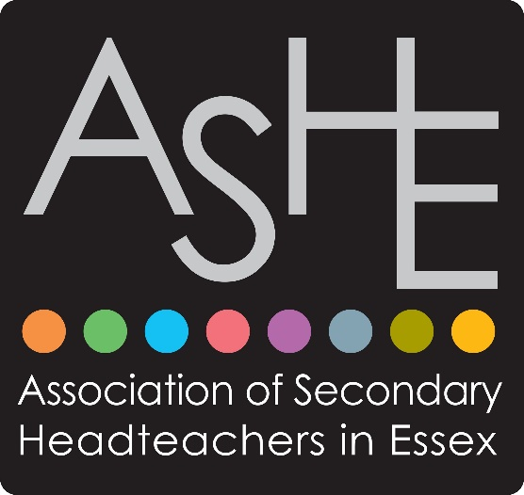
ASHE Annual Conference 2026
‘The Language of Leadership’

Book your place as soon as possible

Dates: 18th to 20th November 2026
Venue: Stoke By Nayland Golf Resort, Colchester
CO6 4PZ

Programme for Thursday 19th November 2026

David Cameron – Our Conference Facilitator
David Cameron is a highly experienced educator and a fantastic speaker, known to all as the ‘Real David Cameron’ to differentiate him from some guy who used to be in the news. He will facilitate our conference over both days and will chair our panel on day one.
Patrick Cozier – Calm Leadership
Patrick Cozier is an experienced Headteacher, member of the Headteacher’s Roundtable and is a trustee on the national charity ‘Show Racism the Red Card.’ Drawing on 24 years of experience, he offers a candid and personal account of his school leadership journey. Since becoming a Headteacher in 2006, Patrick has navigated through the complexities of the role, and learned to do so calmly, developing his Calm Leadership model, assisting leaders with managing stress, staying well and maintaining a positive outlook. His central message is that leadership does not have to mean burnout; with the right mindset and strategies, it can be a source of joy, fulfilment and lasting impact.
Justin Robbins and Karen Dempster: The Language of Partnership: Designing the Parent Relationships Your School Needs

In this practical and thought-provoking session, Karen Dempster and Justin Robbins, authors of The Four Pillars of Parental Engagement, will help school leaders step back from the daily noise of parent communication and consider a more strategic question: What relationship do we actually want with parents, and what are we doing intentionally to create it?

The session will connect directly with the conference theme, The Language of Leadership, by exploring how the language, systems, behaviours and habits of schools shape trust with parents. It will also address the realities facing secondary leaders: attendance, behaviour, safeguarding, SEND, complaints, pupil motivation, staff workload, post-COVID parent expectations and the need to build stronger school communities.

Andy Samways: Better Teacher Habits for Better Student Learning
Andy Samways is the Director of Learning and Innovation at Zenith Multi-Academy Trust.
Highly respected in the world of evidence informed education, teacher training and leadership development, Andy will explore how behavioural science strategies can help teachers develop more effective habits, ultimately leading to improved student learning.
Drawing on the latest research and practical models, Andy will examine why habits are both the foundation of great teaching and a barrier to further growth. He will explore how the most effective professional development can be designed through building knowledge, motivating teachers, developing practical techniques, and embedding new practices.

Michael Fullan – pre-recorded contribution – ‘What the Best Leaders Do to Help Their Organisation Survive and Thrive’

Michael Fullan is the former Dean of the Ontario Institute for Studies in Education and Professor Emeritus at the University of Toronto.

Many delegates will know and have been influenced by Michael’s book ‘Leading in a Culture of Change.’ In his new work, ‘The Six Secrets of Change,’ Michael delivers his signature approach to leading organisations through shifts in consumer taste, politics, markets and trends. He offers simple, time-tested lessons to help leaders cultivate collegiality in teams, build long-range plans that maintain adaptability while being specific enough to offer real guidance. In this pre-recorded presentation, he will advocate for a human paradigm centred on collaborative bottom-up leadership that prioritises moral purpose over rigid top-down mandates.

Panel Discussion, ‘How do you survive and thrive?’ chaired by David Cameron.

Colleagues with diverse experiences in creativity, innovation, entrepreneurship, the third sector, coaching, and with direct involvement in schools, respond to Michael Fullan, and share their own perspectives.

Programme for Friday 20th November 2026

Susie Dent: The Language of Leadership: Inspiring our teams

Susie Dent is a lexicographer, author, broadcaster, and resident word expert on the TV programme ‘Countdown.’

In this presentation, Susie Dent will explore the distinct vocabulary, hidden codes and unwritten rules we utilise in our professional lives, revealing how the words leaders choose can either alienate or weld team members together.

Moving away from sterile corporate jargon and generic buzzwords, Susie will explore how authentic, tailored communication builds psychological safety, trust and deep team loyalty.

Sarah Rozenthuler: Now We’re Talking: How to Discuss What Really Matters

Sarah Rozenthuler is an international keynote speaker, chartered psychologist and published author. With over 20 years of experience working globally at senior levels in start-ups, SMEs and large, complex, global organisations, Sarah brings extensive expertise in executive coaching, team coaching, board facilitation and leadership development consulting.

Research says that 70% of managers avoid having difficult conversations. This leads to poor decision making and a cynical atmosphere that rots communication, with people competing rather than collaborating. Avoiding difficult conversations saps our energy, leaves us feeling stuck, and blocks positive outcomes.

This session is designed to help to overcome the obstacles to difficult conversations by using ‘authentic dialogue’ tools to move from avoidance or breakdown to breakthrough.

Richard Gerver: The Multi-Lingual Language of Leadership

Richard is a former Headteacher, author of five internationally acclaimed books and keynote speaker to the world’s most demanding organisations. He spent twenty years teaching children they were more capable than the adults around them believed. He has spent the last twenty telling corporations the same thing. He believes the lesson has not changed at all!

In his closing keynote, Richard will explore the lessons in leadership learnt from his two decades away from Headship. He will share insights from his meetings with Nobel prize winners, globally renowned CEOs and world leaders. He will use his experience to help respond to one of the great challenges for those at the heart of education, as we seek to understand how we can best prepare ourselves and future generations, for a world of accelerating change and uncertainty.

Booking Options:
Please note the conference is heavily subsidised by
ASHE. This enables us to recruit first class
speakers as well as an informal social programme.

Option 1
Resident on Wednesday 18th and Thursday 19th November. (Breakfast
included). Attendance at Pre-conference dinner on the evening of
Wednesday 18th November. Attendance at Main-conference dinner on
Thursday evening 19th Nov. Full attendance for all speakers on both days
Cost £620

Option 2
Resident on Thursday 19th only (Breakfast included). Attendance at Main-
conference dinner on the evening of Thursday 19th November. Full
attendance at the conference on both days including all speakers on both
days.
Cost £500

Option 3
Non-Resident
Attendance at Main-conference dinner on Thursday evening 19th
November. Full attendance for all speakers on both days (Non-resident)
Cost £400

Option 4
Non-Resident
Full attendance for all speakers on both days. No conference dinners.
Cost £300

Option 5
Non-Resident
Attendance at the conference on either Thursday 19th or Friday 20th
(please specify which day when booking)
Cost £270

Please email your booking by Monday 21st September to
Karen Kerridge (karenkerridge.ashe@gmail.com) including which booking option you would like. Schools will then be invoiced. Please provide the name and email address for the participant and state which option they are booking. If Option 5 please state date. Please also confirm the name of the school when booking.

